Real Estate Marketplace

Investigatory Project Work

Submitted By
Mathews Jaison -12A

Under the Guidance of
Mrs. Bharati Rameshbhai Patel

CERTIFICATE

This is to certify that Mathews Jaison of Class 12A has prepared the investigatory project in Computer Science entitled Real Estate Marketplace. The report is the result of his/her efforts and endeavours. The report is found worthy of acceptance as the final project report for the subject Computer Science of Class XII. He has prepared this report under my guidance.

Internal Examiner: Signature:
Name:

External Examiner: Signature:
Name:

ACKNOWLEDGEMENT

I would like to thank my Computer Science teacher, Mrs. Bharati Rameshbhai Patel, for teaching me the foundations and basics of coding, which strengthened my confidence in being able to make this project. I would also like to thank my friends for aiding me in brainstorming ideas and executing them.

Name of the Student: Mathews Jaison Signature:

CONTENT

- Introduction 5
- Python 5
- SQL(Structured Query Language) 5
- Tkinter 6
- Overview 7
- System Requirements 7
- Source Code 8
- Python code 8
- SQL Database 40
- Output 47
- Shortcomings 48
- Bibliography 48

INTRODUCTION

Python:
Python is a computer programming language often used to build websites and software, automate tasks, and conduct data analysis. Python is a general-purpose language, meaning it can be used to create a variety of different programs and isn’t specialized for any specific problems. This versatility, along with its beginner-friendliness, has made it one of the most-used programming languages today.
Python is commonly used for developing websites and software, task automation, data analysis, and data visualization. Since it’s relatively easy to learn, Python has been adopted by many non-programmers such as accountants and scientists, for a variety of everyday tasks, like organizing finances.

SQL (Structured Query Language) :
SQL stands for Structured Query Language. SQL is used to communicate with a database. According to ANSI (American National Standards Institute), it is the standard language for relational database management systems. SQL statements are used to perform tasks such as update data on a database, or retrieve data from a database. Some common relational database management systems that use SQL are: Oracle, Sybase, Microsoft SQL Server, Access, Ingres, etc.
Although most database systems use SQL, most of them also have their own additional proprietary extensions that are usually only used on their system. However, the standard SQL commands such as “Select”, “Insert”, “Update”, “Delete”, “Create”, and “Drop” can be used to accomplish almost everything that one needs to do with a database

Tkinter :
Tkinter is the de facto way in Python to create GUIs and is included in all standard Python Distributions. In fact, it’s the only framework built into the Python standard library.
This Python framework provides an interface to the Tk toolkit and works as a thin object-oriented layer on top of Tk. The Tk toolkit is a cross-platform collection of ‘graphical control elements’, aka widgets, for building application interfaces.

This framework provides Python users with a simple way to create GUI elements using the widgets found in the Tk toolkit. Tk widgets can be used to construct buttons, menus, data fields, etc. in a Python application. Once created, these graphical elements can be associated with or interact with features, functionality, methods, data or even other widgets.

Overview
This application is a replica of a real estate marketplace where you would be able to look through different property listings in Qatar.
At first, a login page appears where the user inputs his login ID and password. In case the user doesn’t have an account, he/she can create an account by clicking on the create account button.
Once the user logs in, the application shows information of the property listings. It displays the name, address, area, type, contact and picture of each listing There is a filter option where the user can select their preferred location, price and area of the property with the help of drop-down menus.

System Requirements
For development:
OS: Windows 7 SPI+, 8, 10, 64-bit versions only; macOS 10.11 + 4GB RAM or more

For running the application software:

- MySQL Workbench
- Python 3
- MySQL, Tabulate, Tkinter and Random Module

Source Code
Python:
import tkinter as tk
import tkinter as ttk
from tkinter import ttk
import mysql.connector as pys
from PIL import Image, ImageTk

root = tk.Tk()
root.state('zoomed')
root.title('Q-Properties')

mydb = pys.connect(
host = '127.0.0.1',
user = 'root',
passwd = '123456789',
database ='project1')

trashcan=[]

back='#800000'
front='#F8F2ED'
textc2 = '#800000'
txtc = '#F8F2ED'

# ----SQL------------------------------------------------------------------------------------------
sqname=[]
sqadd=[]
sqroom=[]
sqfloor=[]
sqprice=[]
sqcontact=[]
sqpict = []

cur = mydb.cursor()
cur.execute('select nam from properties')
data = cur.fetchall()
for i in data:
sqname.append(i[0])

cur.execute('select address from properties')
data = cur.fetchall()
for i in data:
sqadd.append(i[0])

cur.execute('select area from properties')
data = cur.fetchall()
for i in data:
sqroom.append(i[0])
cur.execute('select type0 from properties')
data = cur.fetchall()
for i in data:
sqfloor.append(i[0])
cur.execute('select price from properties')
data = cur.fetchall()
for i in data:
sqprice.append(i[0])
cur.execute('select contact from properties')
data = cur.fetchall()
for i in data:
sqcontact.append(i[0])
cur.execute('select pict from properties')
data = cur.fetchall()
for i in data:
sqpict.append(i[0])

# ----Pictures------------------------------------------------------------------------------------------

# ----Scrollbar & Frame 3------------------------------------------------------------------------------------------

frame3 = tk.Frame(root,bg=back)
frame3.place(relx=0,rely=0.35, relwidth=1, relheight=1, anchor='nw')

container = ttk.Frame(frame3)
canvas = tk.Canvas(container, bg='#800000', width=1900, height=655)
scrollbar = ttk.Scrollbar(container, orient="vertical", command=canvas.yview)
scrollable_frame = tk.Frame(canvas)
scrollable_frame.bind(
"<Configure>",
lambda e: canvas.configure(
scrollregion=canvas.bbox("all")
)
)
canvas.create_window((0, 0), window=scrollable_frame, anchor="nw")
canvas.configure(yscrollcommand=scrollbar.set)

# ----Content page------------------------------------------------------------------------------------------

x=len(sqname)

def listem(x):

for i in range(x):

listing = tk.Frame(scrollable_frame, bg=front, width=1900, height=200, relief='raised', bd=7)
listing.pack(side='bottom')

listname = ttk.Label(listing, text='Edens Villa', background=front, foreground=textc2, font=('Arial Bold', 18),wraplength=200,justify='center')
listname.place(relx=0.1, rely=0.5, relwidth=0.13, height=70, anchor='center')

lsep_frame = tk.Frame(listing, bg=back)
lsep_frame.place(relx=0.1625, rely=0, relwidth=0.001, relheight=1, anchor='nw')

listadd = ttk.Label(listing, text='1', background=front, foreground=textc2, font=('Arial', 16),wraplength=250, justify='center')
listadd.place(relx=0.283, rely=0.5, width=300, height=100, anchor='center')

lsep_frame2 = tk.Frame(listing, bg=back)
lsep_frame2.place(relx=0.363, rely=0, relwidth=0.001, relheight=1, anchor='nw')

listroom = ttk.Label(listing, text='1440 sq.ft ', background=front, foreground=textc2, font=('Arial', 14),wraplength=300)
listroom.place(relx=0.44, rely=0.5, relwidth=0.08, height=100, anchor='center')

lsep_frame3 = tk.Frame(listing, bg=back)
lsep_frame3.place(relx=0.475, rely=0, relwidth=0.001, relheight=1, anchor='nw')

listfloor = ttk.Label(listing, text='2 Bed\n1 Bath', background=front, foreground=textc2, font=('Arial', 14),wraplength=300)
listfloor.place(relx=0.5425 , rely=0.5, width = 200, height=100, anchor='center')

lsep_frame4 = tk.Frame(listing, bg=back)
lsep_frame4.place(relx=0.5632, rely=0, relwidth=0.001, relheight=1, anchor='nw')

listprice = ttk.Label(listing, text='$2590/mo ', background=front, foreground=textc2, font=('Arial', 14),wraplength=250)
listprice.place(relx=0.635, rely=0.5, width=200, height=100, anchor='center')

lsep_frame5 = tk.Frame(listing, bg=back)
lsep_frame5.place(relx=0.675, rely=0, relwidth=0.001, relheight=1, anchor='nw')

listcontact = ttk.Label(listing, text='55479864 ', background=front, foreground=textc2, font=('Arial', 14),wraplength=250)
listcontact.place(relx=0.76, rely=0.5, relwidth=0.1, height=100, anchor='center')

lsep_frame6 = tk.Frame(listing, bg=back)
lsep_frame6.place(relx=0.800, rely=0, relwidth=0.001, relheight=1, anchor='nw')

listname.config(text=str(sqname[x-1]))
listadd.config(text=str(sqadd[x-1]))
listroom.config(text=str(sqroom[x-1]))
listfloor.config(text=str(sqfloor[x-1]))
listprice.config(text=str(sqprice[x-1]))
listcontact.config(text=str(sqcontact[x-1]))

img= (Image.open(sqpict[x-1]))
resized_image= img.resize((300,205), Image.Resampling.LANCZOS)
new_image= ImageTk.PhotoImage(resized_image)
trashcan.append(new_image)
label = tk.Label(listing, image = new_image)
label.place(relx=0.808, rely=0.49,width=350,height=175, anchor='w')

x-=1

container.pack()
canvas.pack(side="left", fill="both", expand=True)
scrollbar.pack(side="right", fill="y")

def filterclick():
global scrollable_frame,sqname,sqadd ,sqroom ,sqfloor,sqprice,sqcontact,sqpict

a = option_var1.get()
b = option_var2.get()
c = option_var3.get()

f1 = ''
f2 = ''
f3 = ''
f4 = 0
f5 = 0

if a=='West Bay':
f1=a
elif a=='The Pearl':
f1=a
elif a=='Al Sadd':
f1=a
elif a=='Al Waab':
f1=a
elif a=='Lusail':
f1=a

if b=='Any':
f2 = 0
f3 = 999999
elif b=='QR.0-QR.19999':
f2=0
f3=19999
elif b=='QR.20000-QR.39999':
f2=20000
f3=39999
elif b=='QR.40000-QR.59999':
f2=40000
f3=59999
elif b=='QR.60000-QR.79999':
f2=60000
f3=79999
elif b=='QR.80000+':
f2=80000
f3=999999

if c=='Any':
f4 = 0
f5= 99999
elif c=='0-999 sq.ft':
f4=0
f5=999
elif c=='1000-2999 sq.ft':
f4=1000
f5=2999
elif c=='3000-4999 sq.ft':
f4=3000
f5=4999
elif c=='5000+ sq.ft':
f4=5000
f5=99999

# print(a,b,c)
# print(f1,f2,f3,f4,f5)
print("Button works")

sqname=[]
sqadd=[]
sqroom=[]
sqfloor=[]
sqprice=[]
sqcontact=[]
sqpict = []

cur = mydb.cursor()
cur.execute('select x.nam,address,area,type0,price,contact,pict from properties x, properties1 y where x.nam=y.nam and address1 =(%s) and price1>(%s) and price1<(%s) and area1>(%s) and area1<(%s)',(f1,f2,f3,f4,f5,))
data = cur.fetchall()
for i in data:
sqname.append(i[0])
sqadd.append(i[1])
sqroom.append(i[2])
sqfloor.append(i[3])
sqprice.append(i[4])
sqcontact.append(i[5])
sqpict.append(i[6])

x=len(sqname)

scrollable_frame.destroy()

scrollable_frame = tk.Frame(canvas)
scrollable_frame.bind(
"<Configure>",
lambda e: canvas.configure(
scrollregion=canvas.bbox("all")
)
)
canvas.create_window((0, 0), window=scrollable_frame, anchor="nw")

canvas.configure(yscrollcommand=scrollbar.set)

listem(x)

# ----Listings--------------------------------------------------------------------------------------------------------

listem(x)

# ----Title Frame------------------------------------------------------------------------------------------------------
frame1 = tk.Frame(root, background=back)
frame1.place(relx=0, rely=0, relwidth=1, relheight=0.15, anchor='nw')

titlehead=ttk.Label(frame1,text='Q-PROPERTIES',background=back,foreground=txtc,font=('Bauhaus 93',35))
titlehead.place(relx=0.4, rely=0.5, anchor='w' )

# ----Filter Frame------------------------------------------------------------------------------------------------------
frame2 = tk.Frame(root, background=back)
frame2.place(relx=0, rely=0.15, relwidth=1, relheight=0.1, anchor='nw')

fsep_frame2 = tk.Frame(frame2, bg=front)
fsep_frame2.place(relx=0, rely=0, relwidth=1, relheight=0.02, anchor='nw')

label1 = tk.Label(frame2, text='Filters:', font=('Berlin Sans FB', 30),background=back,foreground=txtc)
label1.place(rely=0.475, relx=0.02, anchor='w')

label1 = tk.Label(frame2, text='Location:', font=('Berlin Sans FB', 15),background=back,foreground=txtc)
label1.place(rely=0.5, relx=0.115, anchor='w')

locations = ('West Bay', 'The Pearl', 'Al Sadd','Lusail', 'Al Waab')

option_var1 = tk.StringVar()

def option_changed( *args):
pass

option_menu1 = ttk.OptionMenu(frame2,option_var1,locations[0],*locations,command=option_changed, )
option_menu1.place(rely=0.5, relx=0.16, anchor='w', width=100, height =30)

label1 = tk.Label(frame2, text='Price:', font=('Berlin Sans FB', 15),background=back,foreground=txtc)
label1.place(rely=0.5, relx=0.27, anchor='w')

price = ('Any','QR.0-QR.19999', 'QR.20000-QR.39999','QR.40000-QR.59999','QR.60000-QR.79999','QR.80000+')

option_var2 = tk.StringVar()

def option2_changed( *args):
pass

option_menu2 = ttk.OptionMenu(frame2,option_var2,price[0],*price,command=option2_changed)
option_menu2.place(rely=0.5, relx=0.3, anchor='w',width=140, height =30)

label1 = tk.Label(frame2, text='Area:', font=('Berlin Sans FB', 15),background=back,foreground=txtc)
label1.place(rely=0.5, relx=0.422, anchor='w')

bed = ('Any','0-999 sq.ft','1000-2999 sq.ft', '3000-4999 sq.ft','5000+ sq.ft')

option_var3 = tk.StringVar()

def option3_changed( *args):
pass

option_menu3 = ttk.OptionMenu(frame2,option_var3,bed[0],*bed,command=option3_changed)
option_menu3.place(rely=0.5, relx=0.45, anchor='w',width=120, height =30)

searchbtn=ttk.Button(frame2,text='Search', command= filterclick)
searchbtn.place(rely=0.5, relx=0.85, anchor='w', width=130, height=35)

# ----ColumnFrame-------------------------------------------------------------------------------------------------------
frame4 = tk.Frame(root, background=back)
frame4.place(relx=0, rely=0.25,width=1900, relheight=0.1, anchor='nw')

fillframe = tk.Frame(root, background=back)
fillframe.place(relx=0.95, rely=0.252,width=100, relheight=0.098, anchor='nw')

sep_frame=tk.Frame(frame4, bg=front)
sep_frame.place(relx=0, rely=0, relwidth=1, relheight=0.02, anchor='nw')

sep_frame2=tk.Frame(frame4, bg=front)
sep_frame2.place(relx=0.166, rely=0, relwidth=0.001, relheight=1, anchor='nw')

c_name=ttk.Label(frame4,text='Name',background=back,foreground=txtc,font=('Arial Bold',17))
c_name.place(relx=0.06, rely=0.5,relwidth=0.08,relheight=0.5, anchor='w' )

sep_frame3=tk.Frame(frame4, bg=front)
sep_frame3.place(relx=0.3649, rely=0, relwidth=0.001, relheight=1, anchor='nw')

c_address=ttk.Label(frame4,text='Address',background=back,foreground=txtc,font=('Arial Bold',17))
c_address.place(relx=0.24, rely=0.5,relwidth=0.11,height=50, anchor='w' )

sep_frame4=tk.Frame(frame4, bg=front)
sep_frame4.place(relx=0.476, rely=0, relwidth=0.001, relheight=1, anchor='nw')

c_rooms=ttk.Label(frame4,text='Area',background=back,foreground=txtc,font=('Arial Bold',17))
c_rooms.place(relx=0.407, rely=0.5,relwidth=0.04,height=50, anchor='w' )

sep_frame5=tk.Frame(frame4, bg=front)
sep_frame5.place(relx=0.5632, rely=0, relwidth=0.001, relheight=1, anchor='nw')

c_floor=ttk.Label(frame4,text='Type',background=back,foreground=txtc,font=('Arial Bold',17))
c_floor.place(relx=0.505, rely=0.5,relwidth=0.05,height=50, anchor='w' )

sep_frame6=tk.Frame(frame4, bg=front)
sep_frame6.place(relx=0.674, rely=0, relwidth=0.001, relheight=1, anchor='nw')

c_price=ttk.Label(frame4,text='Price',background=back,foreground=txtc,font=('Arial Bold',17))
c_price.place(relx=0.6, rely=0.5,relwidth=0.05,height=50, anchor='w' )

sep_frame7=tk.Frame(frame4, bg=front)
sep_frame7.place(relx=0.799, rely=0, relwidth=0.001, relheight=1, anchor='nw')

c_contact=ttk.Label(frame4,text='Contact',background=back,foreground=txtc,font=('Arial Bold',17))
c_contact.place(relx=0.71, rely=0.5,relwidth=0.08,height=50, anchor='w' )

c_picture=ttk.Label(frame4,text='Picture',background=back,foreground=txtc,font=('Arial Bold',17))
c_picture.place(relx=0.865, rely=0.5,relwidth=0.18,height=50, anchor='w' )

'''
# ----Create Account Frame-----------------------------------------------------------------------------------------

seller_frame=tk.Frame(root,bg=back)
seller_frame.place(relx=0,rely=0,relwidth=1, relheight=1)

f6title=tk.Label(seller_frame,text="CREATE LISTING",font=("Arial Bold",60),fg=front,bg=back)
f6title.place(relx=0.295, rely=0.1,)

#listname
f6name=tk.Label(seller_frame,text="Listing Name:",font=("",18),fg=front,bg=back)
f6name.place(relx=0.3,rely=0.3)

f6namentry=tk.Entry(seller_frame,bg='#ac8279',fg=front,width=35,font='Arial 14')
f6namentry.place(relx=0.3,rely=0.35,relwidth=0.15,relheight=0.045)

#location
f6location=tk.Label(seller_frame,text="Location:",font=("",18),fg=front,bg=back)
f6location.place(relx=0.5,rely=0.3)

locations = ('West Bay', 'The Pearl', 'Al Sadd','Lusail', 'Al Waab')
option_var1 = tk.StringVar()
def option_changed( *args):
pass
option_menu1 = ttk.OptionMenu(seller_frame,option_var1,locations[0],*locations,command=option_changed, )
option_menu1.place(rely=0.375, relx=0.5, anchor='w', width=150, height =40)

#address
f6add=tk.Label(seller_frame,text="Address:",font=("wdwdwq",18),fg=front,bg=back)
f6add.place(relx=0.3,rely=0.45)

f6addentry=tk.Entry(seller_frame,bg='#ac8279',fg=front,font='Arial 14',width=35)
f6addentry.place(relx=0.3,rely=0.5,relwidth=0.35,relheight=0.045)

f6bed=tk.Label(seller_frame,text="Bed/Bath:",font=("wdwdwq",18),fg=front,bg=back)
f6bed.place(relx=0.3,rely=0.6)

f6bedentry=tk.Entry(seller_frame,bg='#ac8279',fg=front,font='Arial 14',width=35)
f6bedentry.place(relx=0.3,rely=0.65,relwidth=0.15,relheight=0.045)

f6area=tk.Label(seller_frame,text="Area:",font=("wdwdwq",18),fg=front,bg=back)
f6area.place(relx=0.5,rely=0.6)

f6areaentry=tk.Entry(seller_frame,bg='#ac8279',fg=front,font='Arial 14',width=35)
f6areaentry.place(relx=0.5,rely=0.65,relwidth=0.15,relheight=0.045)

f6num=tk.Label(seller_frame,text="Mobile no:",font=("wdwdwq",18),fg=front,bg=back)
f6num.place(relx=0.3,rely=0.75)

f6numentry=tk.Entry(seller_frame,bg='#ac8279',fg=front,font='Arial 14',width=35)
f6numentry.place(relx=0.3,rely=0.8,relwidth=0.35,relheight=0.045)

def lmao(event):
u= f2usentry.get()
v= f2pswdentry.get()
h = f2repswdentry.get()
if u =='' or v=='':
f2error=ttk.Label(create_frame,text='Enter Valid username or password!',background=front,foreground=back,font=('',14))
f2error.place(relx=0.38,rely=0.7,relwidth=0.38,relheight=0.045)
else:
if u in squser:
f2error=ttk.Label(create_frame,text='Username already taken. Please try again',background=front,foreground=back,font=('',14))
f2error.place(relx=0.38,rely=0.64,relwidth=0.38,relheight=0.045)

elif v != h:
f2error=ttk.Label(create_frame,text='Incorrect password. Please try again',background=front,foreground=back,font=('',14))
f2error.place(relx=0.38,rely=0.7,relwidth=0.38,relheight=0.045)

else:
cur.execute('insert into accounts values((%s),(%s))',(u,v,))
mydb.commit()
f2error=ttk.Label(create_frame,text='Account created!',background=front,foreground=back,font=('',14))
f2error.place(relx=0.45,rely=0.7,relwidth=0.38,relheight=0.045)

create=tk.Button(create_frame,text='CREATE',fg=front,bg=back,font=('Arial Bold',18),command=lambda : lmao('sddsd'))
create.place(relx=0.42,rely=0.75, relwidth=0.15,relheight=0.05 )

#Gobackbutton
lgtacc=tk.Label(create_frame,text="Already have an account?",font=('',13),fg=back,bg=front)
lgtacc.place(relx=0.029, rely=0.89)

lgtbtn=tk.Button(create_frame, text='Login', font=('',11),fg=front,bg=back,width=18,command=lambda: raise_frame(login_frame))
lgtbtn.place(relx=0.015, rely=0.93, relwidth=0.12)

'''

# ----Login--------------------------------------------------------------------------------------------------------

def raise_frame(frame):
frame.tkraise()

login_frame=tk.Frame(root,bg=front)
login_frame.place(relx=0,rely=0,relwidth=1, relheight=1)

create_frame=tk.Frame(root, bg=front)
create_frame.place(relx=0, rely=0, relwidth=1,relheight=1)

#Title
f1title=ttk.Label(login_frame,text="WELCOME!",font=("Arial Bold",60),foreground=back,background=front)
f1title.place(relx=0.38, rely=0.1,)

#Username
usname=ttk.Label(login_frame,text="Username:",font=("",18),foreground=back,background=front)
usname.place(relx=0.3,rely=0.35)

usentry=tk.Entry(login_frame,background='#ac8279',foreground=front,width=35,font='Arial 14')
usentry.place(relx=0.3,rely=0.4,relwidth=0.38,relheight=0.045)

#password
pswd=ttk.Label(login_frame,text="Password:",font=("",18),foreground=back,background=front)
pswd.place(relx=0.3,rely=0.5)

pswdentry=tk.Entry(login_frame, show='*', background='#ac8279',foreground=front,font='Arial 14',width=35)
pswdentry.place(relx=0.3,rely=0.55,relwidth=0.38,relheight=0.045)

#Loginbutton
squser={}
sqpass={}

def lol(event):
cur.execute('select * from accounts')
data = cur.fetchall()
for (i,j) in data:
squser[i]=j

if usentry.get() in squser:
if pswdentry.get()== squser[usentry.get()]:
raise_frame(frame1)
raise_frame(frame2)
raise_frame(frame4)
raise_frame(frame3)
else:
error=ttk.Label(login_frame,text='Wrong email id or password. Please try again',background=front,foreground=back,font=('',14))
error.place(relx=0.38,rely=0.64,relwidth=0.38,relheight=0.045)
login=tk.Button(login_frame,text='LOGIN',bg=back, fg=front,font=('Arial Bold',18),command=lambda : lol('sddsd'))
login.bind('<Return>',lol)
login.place(relx=0.41, rely= 0.7, relwidth=0.15,relheight=0.05 )

#create button text
crtacc=tk.Label(login_frame,text="Don't have an account?",font=('Arial',13),fg=back,bg=front)
crtacc.place(relx=0.032, rely=0.89)

crtbtn=tk.Button(login_frame, text='Create account', font=('',11),fg=front,bg=back, command= lambda :raise_frame(create_frame))
crtbtn.place(relx=0.015, rely=0.93, relwidth=0.12)

# ----Create Account Frame------------------------------------------------------------------------------------------

f2title=tk.Label(create_frame,text="CREATE ACCOUNT",font=("Arial Bold",60),fg=back,bg=front)
f2title.place(relx=0.295, rely=0.1,)

#username
f2usname=tk.Label(create_frame,text="New Username:",font=("",18),fg=back,bg=front)
f2usname.place(relx=0.3,rely=0.3)

f2usentry=tk.Entry(create_frame,bg='#ac8279',fg=front,width=35,font='Arial 14')
f2usentry.place(relx=0.3,rely=0.35,relwidth=0.38,relheight=0.045)

#password
f2pswd=tk.Label(create_frame,text="Password:",font=("wdwdwq",18),fg=back,bg=front)
f2pswd.place(relx=0.3,rely=0.45)

f2pswdentry=tk.Entry(create_frame,bg='#ac8279',fg=front,font='Arial 14',width=35)
f2pswdentry.place(relx=0.3,rely=0.5,relwidth=0.38,relheight=0.045)

f2repswd=tk.Label(create_frame,text="Re-enter Password:",font=("wdwdwq",18),fg=back,bg=front)
f2repswd.place(relx=0.3,rely=0.6)

f2repswdentry=tk.Entry(create_frame,bg='#ac8279',fg=front,font='Arial 14',width=35)
f2repswdentry.place(relx=0.3,rely=0.65,relwidth=0.38,relheight=0.045)

def lmao(event):
u= f2usentry.get()
v= f2pswdentry.get()
h = f2repswdentry.get()
if u =='' or v=='':
f2error=ttk.Label(create_frame,text='Enter Valid username or password!',background=front,foreground=back,font=('',14))
f2error.place(relx=0.38,rely=0.7,relwidth=0.38,relheight=0.045)
else:
if u in squser:
f2error=ttk.Label(create_frame,text='Username already taken. Please try again',background=front,foreground=back,font=('',14))
f2error.place(relx=0.38,rely=0.64,relwidth=0.38,relheight=0.045)

elif v != h:
f2error=ttk.Label(create_frame,text='Incorrect password. Please try again',background=front,foreground=back,font=('',14))
f2error.place(relx=0.38,rely=0.7,relwidth=0.38,relheight=0.045)

else:
cur.execute('insert into accounts values((%s),(%s))',(u,v,))
mydb.commit()
f2error=ttk.Label(create_frame,text='Account created!',background=front,foreground=back,font=('',14))
f2error.place(relx=0.45,rely=0.7,relwidth=0.38,relheight=0.045)

create=tk.Button(create_frame,text='CREATE',fg=front,bg=back,font=('Arial Bold',18),command=lambda : lmao('sddsd'))
create.place(relx=0.42,rely=0.75, relwidth=0.15,relheight=0.05 )

#Gobackbutton
lgtacc=tk.Label(create_frame,text="Already have an account?",font=('',13),fg=back,bg=front)
lgtacc.place(relx=0.029, rely=0.89)

lgtbtn=tk.Button(create_frame, text='Login', font=('',11),fg=front,bg=back,width=18,command=lambda: raise_frame(login_frame))
lgtbtn.place(relx=0.015, rely=0.93, relwidth=0.12)

raise_frame(login_frame)

# ----Login Logic---------------------------------------------------------------------------

root.mainloop()

SQL:
Script1:

create database project1;
use project1;
create table properties
(
Nam char(100),
Address char(100),
Area char(100),
Type0 Char(100),
Price char(100),
Contact integer(100),
pict varchar(100)
);
insert into properties values
("VOCO DOHA","Doha,West Bay,ZigZag Tower","872 sq.ft","Bed:1 , Bath:1","13,500QAR/mo","44955000",'image1.jpeg');
insert into properties values
("FLORESTA GARDENS","Doha,The Pearl,Floresta Gardens","4,811sq.ft","Bed:7 , Bath:7","26,000QAR/mo","44627829",'image2.jpeg');
insert into properties values
("LES ROSES 3","Doha,Al Waab,Les Roses Compound","3,961 sq.ft","Bed:6 , Bath:6","18,857QAR/mo","44627904",'image3.jpeg');
insert into properties values
("LES ROSES COMPOUND 1","Doha,Al Waab,Les Roses Compound","3,401sq.ft","Bed:5 , Bath:6","15,000QAR/mo","44627904",'image4.jpeg');
insert into properties values
("GIARDINO APARTMENTS","Doha,The Pearl,Medina Centrale","872 sq.ft","Bed:1 , Bath:2","10,000QAR/mo","44627946",'image5.jpeg');
insert into properties values
("AL DANA VILLA","Doha,Al Sadd,Al Muraikh","4,424 sq.ft","Bed:3 , Bath:3","18,000QAR/mo","44627878",'image6.jpeg');
insert into properties values
("EAST PORTO VILLA","Doha,The Pearl,Porto Arabia","3,552 sq.ft","Bed:3 , Bath:4","17,000QAR/mo","44627878",'image7.jpeg');
insert into properties values
("AL SADD VILLA","Doha,Al Sadd,C-ring road","753 sq.ft","Bed:1 , Bath:1","11,000QAR/mo","44627879",'image8.jpeg');
insert into properties values
("VIVA BAHRIYA VILLA","Doha,The Pearl,Viva Bahriya ","2,690 sq.ft","Bed:4 , Bath:3","21,000QAR/mo","30500770",'image9.jpeg');
insert into properties values
("PORTO ARABIA","Doha,The Pearl,Medina Centrale","2,822 sq.ft","Bed:3 , Bath:4","40,000QAR/mo'","77886900",'image10.jpeg');
insert into properties values
("WATERFRONT","Doha,Lusail city,Waterfront District","1,528 sq.ft","Bed:2 , Bath:2","50000QAR/mo","77551977",'image11.jpeg');
insert into properties values
("QANAT QUARTIER","Doha,The Pearl,Qanat Quartier ","1,367 sq.ft","Bed:2 , Bath:3","47,000QAR/mo","31319601",'image12.jpeg');
insert into properties values
("STANDALONE VILLA ","Doha,West Bay,Standalone Villa","12,916 sq.ft","Bed:10 , Bath:8","70,000QAR/mo","77987797",'image13.jpeg');
insert into properties values
("AL ERKYAH","Doha,Lusail City,Al Erkyah ","914 sq.ft","Bed:1 , Bath:2","27,000QAR/mo","77551977",'image14.jpeg');
insert into properties values
("AL SADD VILLA 2","Doha,Al Sadd,Al Sadd road","9,364 sq.ft","Bed:6 , Bath:6","90,000QAR/mo","30074740",'image15.jpeg');
insert into properties values
("FOX HILLS APARTMENT","Doha,Lusail,Fox Hills","1,463 sq.ft","Bed:2 , Bath:2","32,000QAR/mo","77551977",'image16.jpeg');
insert into properties values
("LEJBAILAT VILLA ","Doha,Al Sadd,Lejbailat","8,072 sq.ft","Bed:7 , Bath:9","40,000QAR/mo","30074740",'image17.jpeg');
insert into properties values
("WEST BAY LAGOON VILLA","Doha,West bay,Legtaifiya","4,628 sq.ft","Bed:5 , Bath:5","23,000QAR/mo","30500770",'image18.jpeg');
insert into properties values
("PORTO ARABIA PENTHOUSE","Doha,The Pearl,Porto Arabia","9,579 sq.ft","Bed:6 , Bath:5","100,000QAR/mo","30451451",'image19.jpeg');
insert into properties values
("THE PEARL PENTHOUSE","Doha,The Pearl,Qanat Quartier","3,573 sq.ft","Bed:5 , Bath:5","163,000QAR/mo","31319601",'image20.jpeg');

Script2:
use project1;
create table properties1
(
Nam char(100),
Address1 char(100),
Area1 char(100),
Type1 Char(100),
Price1 char(100),
Contact1 integer(100),
pict1 varchar(100)
);
insert into properties1 values
("VOCO DOHA","West Bay","872","Bedroom:1 , Bathroom:1","13500","44955000",'image1.jpeg');
insert into properties1 values
("FLORESTA GARDENS","The Pearl","4811","Bedroom:7 , Bathroom:7","26000","44627829",'image2.jpeg');
insert into properties1 values
("LES ROSES 3","Al Waab","3961","Bedroom:6 , Bathroom:6","18857","44627904",'image3.jpeg');
insert into properties1 values
("LES ROSES COMPOUND 1","Al Waab","3401","Bedroom:5 , Bathroom:6","15000","44627904",'image4.jpeg');
insert into properties1 values
("GIARDINO APARTMENTS","The Pearl","872","Bedroom:1 , Bathroom:2","10000","44627946",'image5.jpeg');
insert into properties1 values
("AL DANA VILLA","Al Sadd","4424","Bedroom:3 , Bathroom:3","18000","44627878",'image6.jpeg');
insert into properties1 values
("EAST PORTO VILLA","The Pearl","3552","Bedroom:3 , Bathroom:4","17000","44627878",'image7.jpeg');
insert into properties1 values
("AL SADD VILLA","Al Sadd","753","Bedroom:1 , Bathroom:1","11000","44627879",'image8.jpeg');
insert into properties1 values
("VIVA BAHRIYA VILLA","The Pearl","2690","Bedroom:4 , Bathroom:3","21000","30500770",'image9.jpeg');
insert into properties1 values
("PORTO ARABIA","The Pearl","2822","Bedroom:3 , Bathroom:4","40000","77886900",'image10.jpeg');
insert into properties1 values
("WATERFRONT","Lusail","1528","Bedroom:2 , Bathroom:2","50000","77551977",'image11.jpeg');
insert into properties1 values
("QANAT QUARTIER","The Pearl","1367","Bedroom:2 , Bathroom:3","47000","31319601",'image12.jpeg');
insert into properties1 values
("STANDALONE VILLA ","West Bay","12916","Bedroom:10 , Bathroom:8","70000","77987797",'image13.jpeg');
insert into properties1 values
("AL ERKYAH","Lusail ","914","Bedroom:1 , Bathroom:2","27000","77551977",'image14.jpeg');
insert into properties1 values
("AL SADD VILLA 2","Al Sadd","9364","Bedroom:6 , Bathroom:6","90000","30074740",'image15.jpeg');
insert into properties1 values
("FOX HILLS APARTMENT","Lusail","1463","Bedroom:2 , Bathroom:2","32000","77551977",'image16.jpeg');
insert into properties1 values
("LEJBAILAT VILLA ","Al Sadd","8072","Bedroom:7 , Bathroom:9","40000","30074740",'image17.jpeg');
insert into properties1 values
("WEST BAY LAGOON VILLA","West bay","4628","Bedroom:5 , Bathroom:5","23000","30500770",'image18.jpeg');
insert into properties1 values
("PORTO ARABIA PENTHOUSE","The Pearl","9579","Bedroom:6 , Bathroom:5","100000","30451451",'image19.jpeg');
insert into properties1 values
("THE PEARL PENTHOUSE","The Pearl","3573","Bedroom:5 , Bathroom:5","163000","31319601",'image20.jpeg');

Script3:
use project1;
create table accounts
(
UserID char(100) not null,
Pass char(100) not null
);
insert into accounts values
("1","2"),
("hisham","alen");

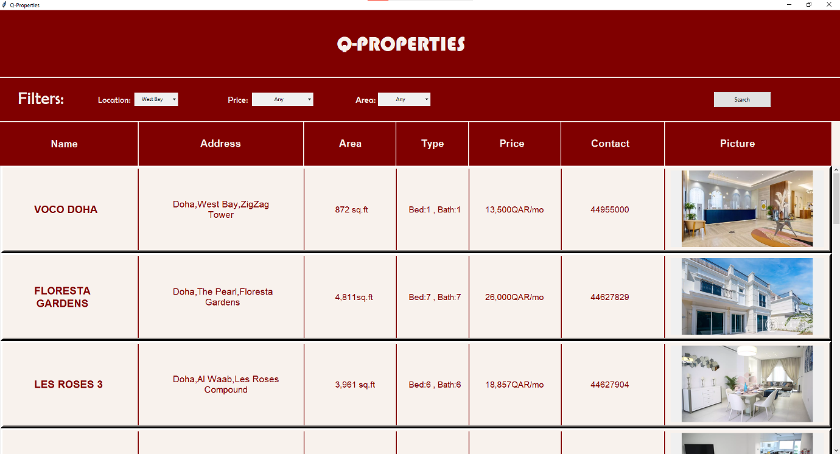
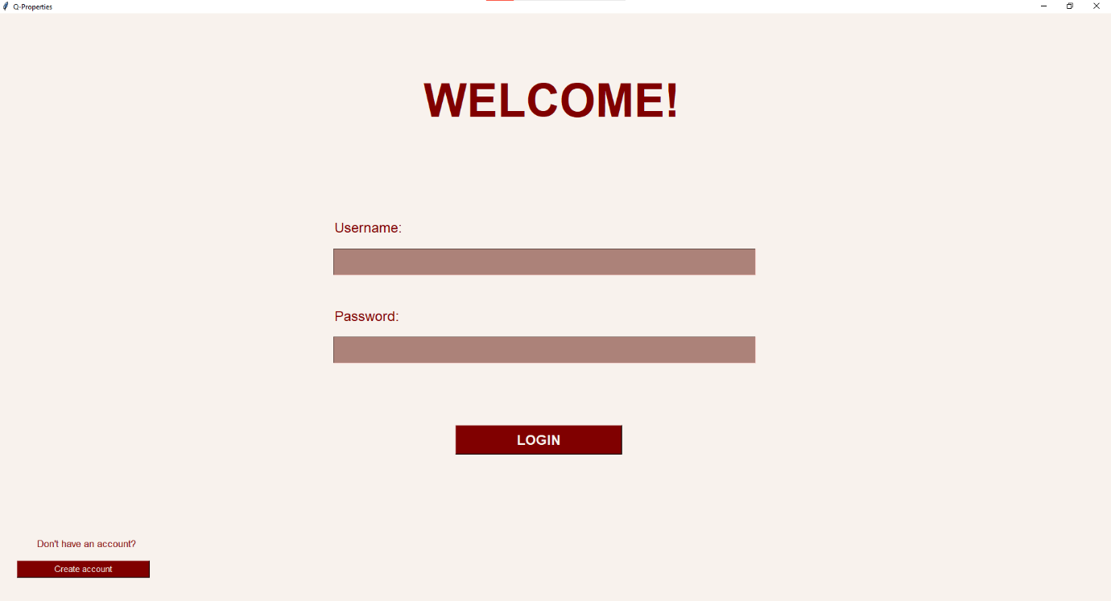
Output

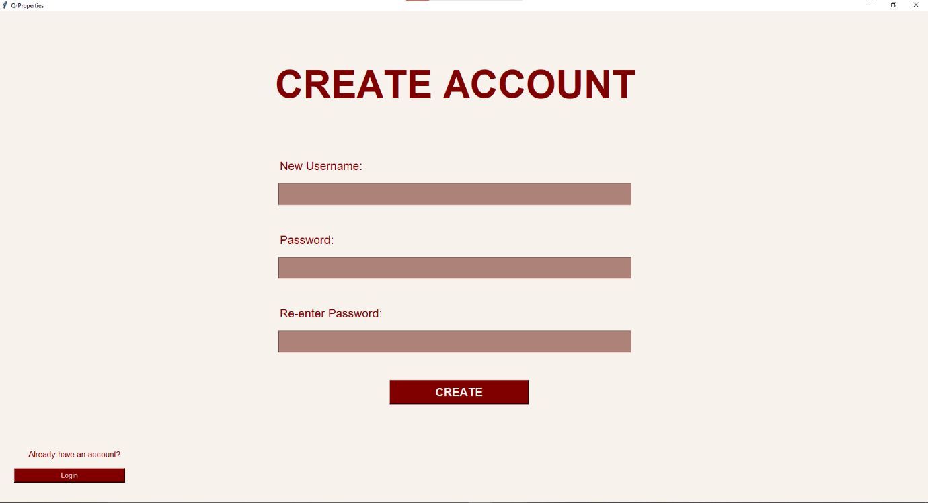
Shortcomings

- The program could have an option for the user to list their own properties
- The user interface could have been more appealing

Bibliography

- https://www.coursera.org/articles/what-is-python-used-for-a-beginners-guide-to-using-python
- https://www.sqlcourse.com/beginner-course/what-is-sql/
- https://www.activestate.com/resources/quick-reads/what-is-tkinter-used-for-and-how-to-install-it/
- https://www.pythontutorial.net/tkinter/

